Project Doc

0 . Cover
Project name: Flat Chat
Team members: Nadir Bašić, Luka Radulovikj, Eric Germersdorf
Date / version: 2026‑05-06

1. Problem Statement & Vision
One‑sentence pitch

“Help Berliners find a good apartment quickly, affordably, and make informed decisions from a comprehensive overview and chat interface”

Why now? / Stakeholders – Pain points, target users, success criteria.

Most current apartment-finding solutions focus on Germany, and on ‘quick’ apartment finding via notifications (be the first to see an apartment).

Ours focuses on ease of use, interactivity and intelligence. We provide the user with a comprehensive overview of apartment listings through conversations with a chatbot - satisfying needs of picky flat hunters, those with special needs, and those who just want an easy experience and no hassle.

Currently the solution for these kinds of users are real estate agents, which are expensive, hard to find, and many don’t provide good service.

Our goal is to provide a real-estate AI agent, focused on Berlin, and delivering a “Apartment hunter ChatGPT” experience.

2 . Scope
Must‑have (MVP): Describe an apartment to a chatbot, get back results visualized on a map and iterate with chatbot until happy with results. Cover most apartment listing websites.
Nice‑to‑have: Contextual information for apartments, including: noise levels, greenery, public transport connectivity, closeness to schools, hospitals… Emergent intelligent behaviour by the agent - suggesting apartments in the way a real real-estate agent would.
Stretch goals: Automated daily searches for users, telegram bot, automated applying to apartments.
Out of scope: Cities other than Berlin, Fair pricing comparison

3 . User Stories
“I’m moving to Berlin in a month from now, and I haven’t yet found an apartment! All of these different websites, forms and applications have gotten me so confused! I wish I could just ask ChatGPT to find me a flat…”

“I want to find an apartment and I’m picky. I want a nice area, good commute, 3 bedrooms, etc. I spend hours researching myself and comparing apartments day to day.”

“I’m tired of juggling multiple sites and endless listings. I want clear, honest summaries so I can quickly find and apply to apartments that actually match my needs.”

“I want to find an apartment to live in long-term for me and my family, but finding one that meets all of our needs is hard. I tried a couple of real-estate agents, but they are pretty expensive and most aren’t very useful…”

4 . System Overview
Still not fully determined, we will keep it agile and make decisions as we go. But the system will probably look something like below:
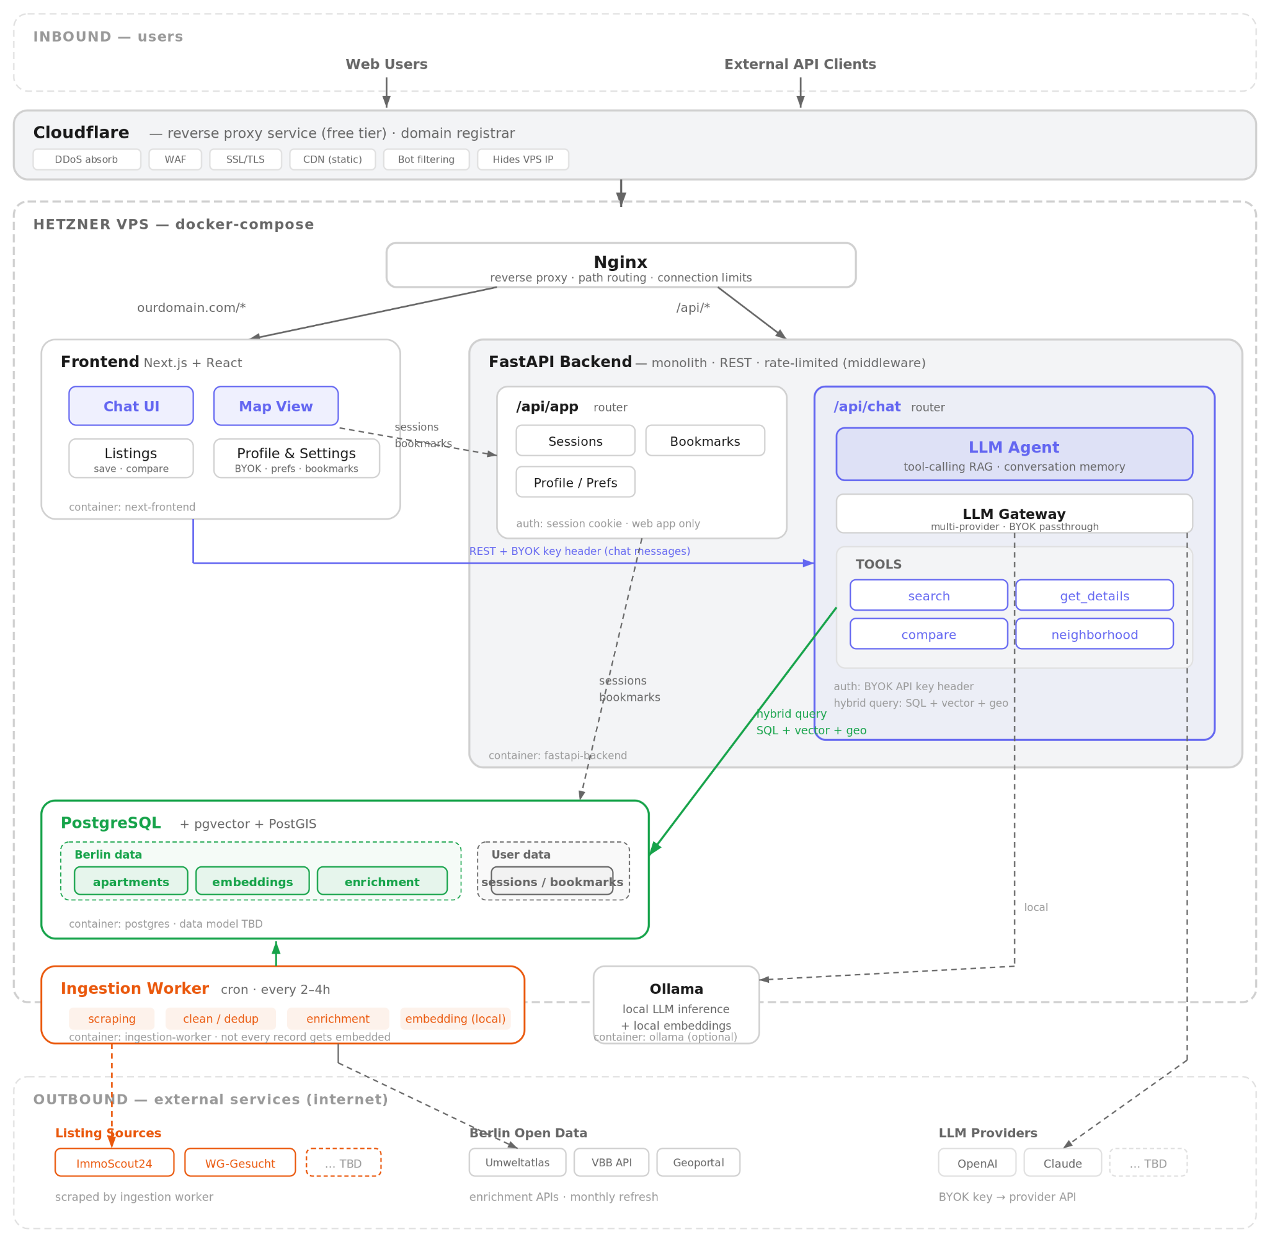
Decisions:
- VPS hosting (e.g Hetzner) is simplest, cheapest, and should be satisfactory on our scale
- Cloudflare's free tier provides DDoS protection, CDN, WAF, and SSL - we can also register our domain through their registrar for seamless integration
- The backend will be a monolith for simplicity, but the chatbot router will be exposed both to the web app and external api clients, e.g telegram bots. We can even plan for more integration and bigger scale, e.g exposing the search MCP API, by keeping things modular and planning on time
- For the MVP, we will implement minimal user management and persist sessions, bookmarks, and enable BYOK for LLM interactions
- On our scale, PostgreSQL can handle the semantic vector search, structured and geo data
- The data ingestion is implemented as a cron job, and will be designed to make minimal requests and comply with all ToS

Tech stack:
- Cloudflare, Nginx
- React, Typescript
- FastAPI, sqlalchemy, [LLM gateway, LLM framework, agent framework, search framework TBD]
- PostgreSQL
- Docker, Docker Compose, Github Actions

6 . Project Plan & Timeline
Week Milestone Owner Deliverable
1-3 Repo, research Eric SW Project Scaffolding, Research doc
4 Ingestion module Luka Scraping, parsing, API clients, DB
5 Search module Nadir Apartment search API
6 Chatbot Luka LLM Agent with search tool use, chatbot backend
7 Frontend Eric Interactive chat and Berlin map
8 UAT, Deployment Nadir Prod URL, UAT results

7 . Roles & Responsibilities
Role Person Key Duties
Product / PM Eric Scope, timeline, domain expertise, data source expert
AI/Software Engineer Luka Data ingestion module, DB
AI/Software Engineer Nadir Chatbot and search development

Decision making process - we will keep it light and agile, and let most decisions be made autonomously. During meetings and PR reviews we can verify some decisions post-hoc. Important decisions will be made together via chat or in meetings.

8 . Risk Register
Risk Probability Impact Mitigation
ToS Violations Medium Medium Compliant service usage, stale data tradeoff
Pricing Medium High Agentless search, caching
Large scope High Low Focus on delivering MVP and not all features

9 . Evaluation & Demo Plan
- Success metrics - positive user acceptance testing, high apartment listing coverage, search results eval, agentic/chat workflow eval
- Demo script – live demo where we ask someone from the audience to describe an apartment they would like to live in, prompt and review results, showcase user profile bookmarks.
- Backup video in case Wi‑Fi fails.

